Markdown Documentation

What is Markdown?

**Markdown** is a lightweight markup language that you can use to add formatting elements to plaintext text documents. **Markdown** is now one of the world’s most popular markup languages. When you create a Markdown-formatted file, you add Markdown syntax to the text to indicate which words and phrases should look different.

For example, to make a heading, you add a number sign before it (e.g., # H1, ## H2). Or to make a phrase bold, you add two asterisks before and after it (e.g., **this text is bold**). It may take a while to get used to seeing Markdown syntax in your text. The screenshot below shows a Markdown file displayed in the Visual Studio Code.

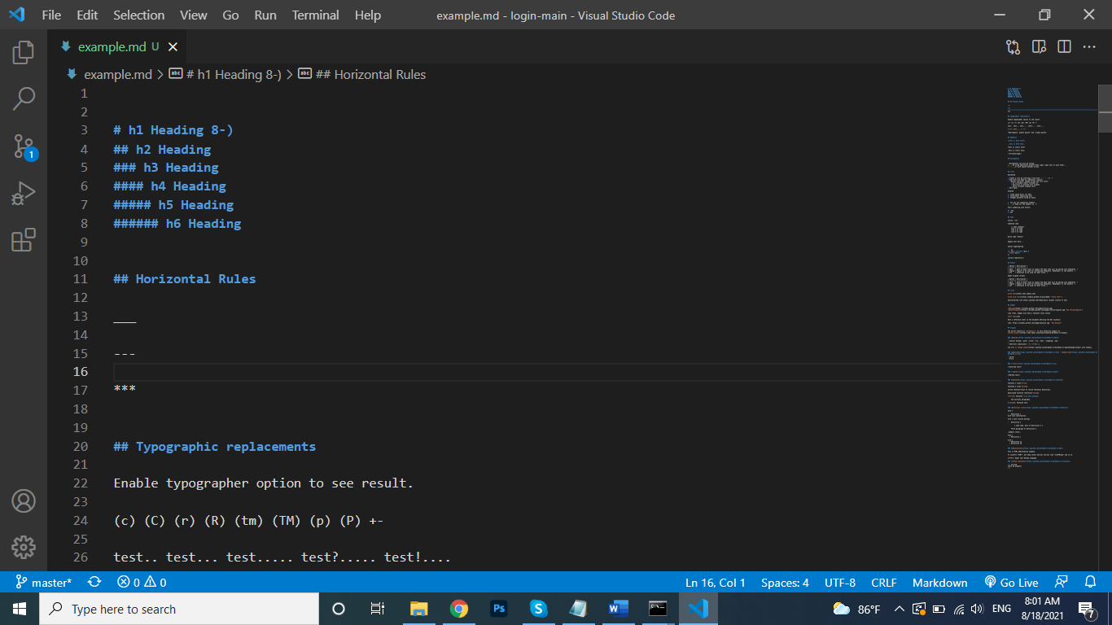

Why Use Markdown?

There are different reasons why people use **Markdown**.

* Markdown can be used for everything. People use it to create *websites*, *documents*, *notes*, *books*, *presentations*, and *technical documentation*.
* Markdown is portable. Files containing Markdown-formatted text can be opened using virtually any application.
* Markdown is platform independent. You can create Markdown-formatted text on any device running any operating system.
* Markdown is everywhere. Websites like **Reddit** and **GitHub** support Markdown, and lots of desktop and web-based applications support it.

How to Use Markdown?

If you want to use **markdown**, you don’t even need to download anything. You can use several text editor, such as **visual studio code**. To summarize, this is a three-part process how to use in visual studio code:

1. Create a Markdown file using a text editor or a dedicated Markdown application. The file should have an **.md** extension.
2. Open the Markdown file in a text editor.
3. Write the Markdown-formatted text in an **.md** file and click the preview appears in the right pane.

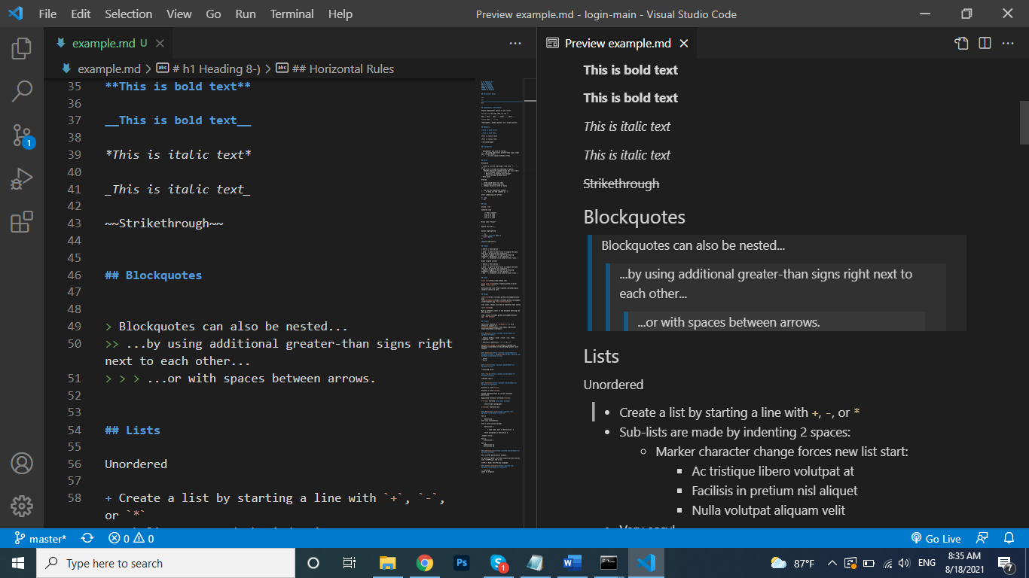

What’s Markdown Good For?

**Markdown** is a fast and easy way to take notes, create content for a website, and produce print-ready documents. It doesn’t take long to learn the Markdown syntax, and once you know how to use it, you can write using Markdown just about everywhere.

Where you can learn Markdown Syntax?

You can learn **markdown syntax** from <https://www.markdownguide.org/cheat-sheet> . And You can [download this cheat sheet as a Markdown file](https://www.markdownguide.org/assets/markdown-cheat-sheet.md) for use in your text editor or markdown application.